Task 5

1. Compress a file by compress, gzip, zip commands and decompress it again. State the differences between compress and gzip commands.

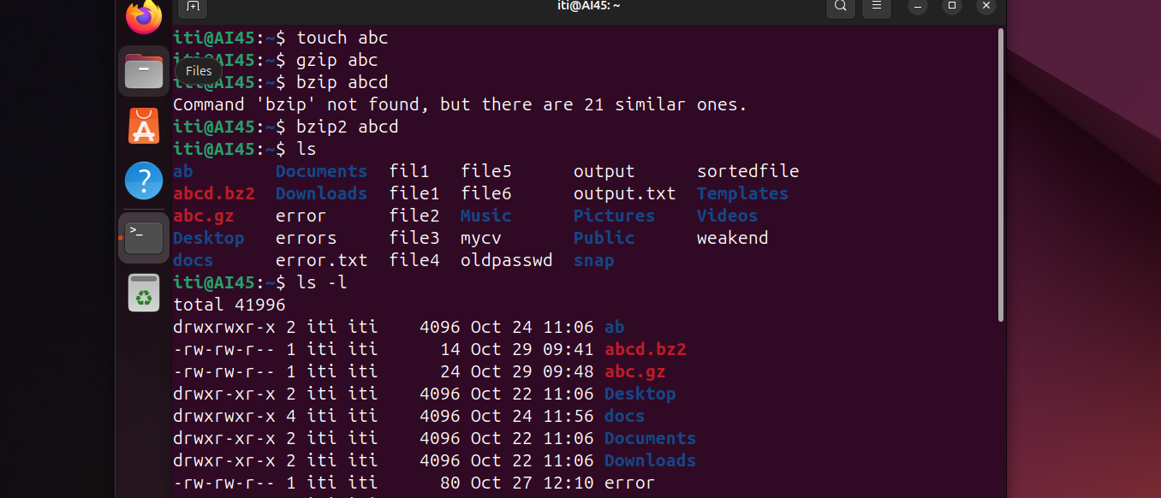

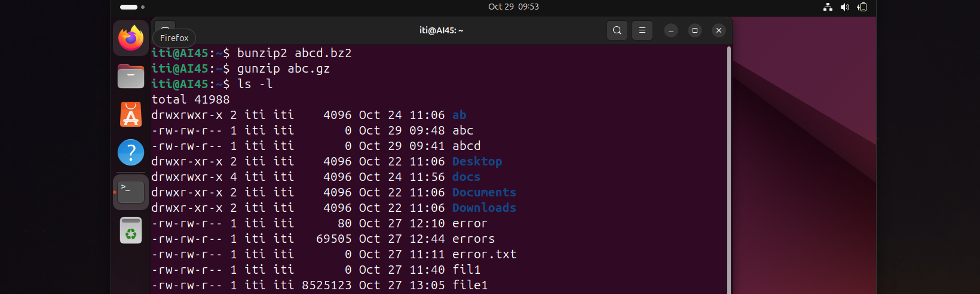

**compress**:

Compressed files have a .Z extension.

Has limited support across systems and is primarily found in older Unix environments.

Has lower compression ratios, generally resulting in larger files compared to gzip.

**gzip**:

Compressed files have a .gz extension.

Supported across nearly all Unix/Linux systems, and widely compatible on Windows and other platforms.

Offers better compression ratios, producing smaller files for the same data.

1. What is the command used to view the content of a compressed file.

Zcat

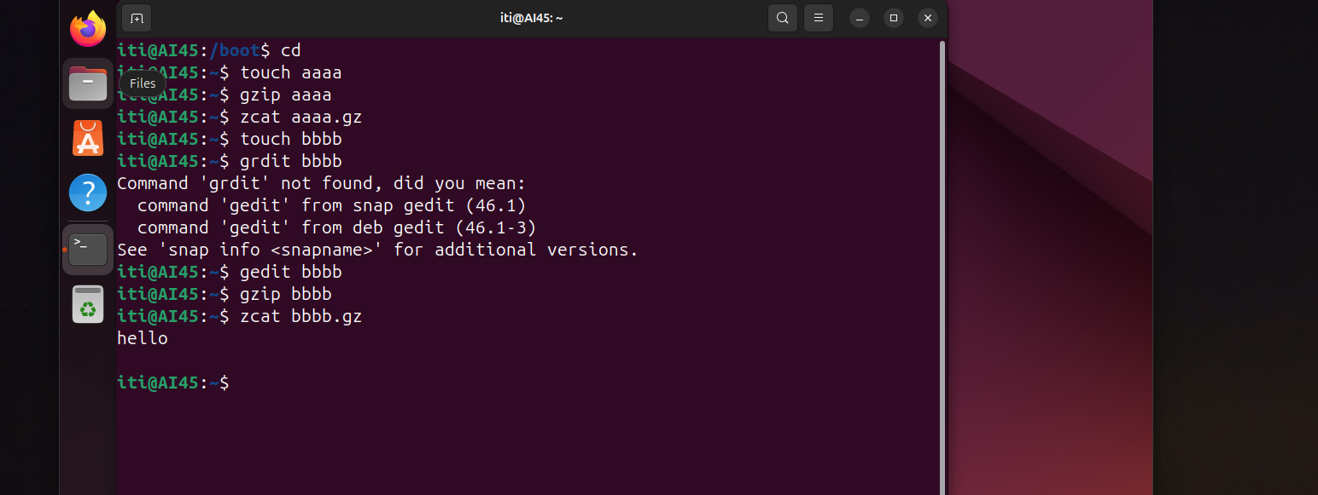

1. Backup /etc directory using tar utility.

1. Starting from your home directory, find all files that were modified in the last two day.

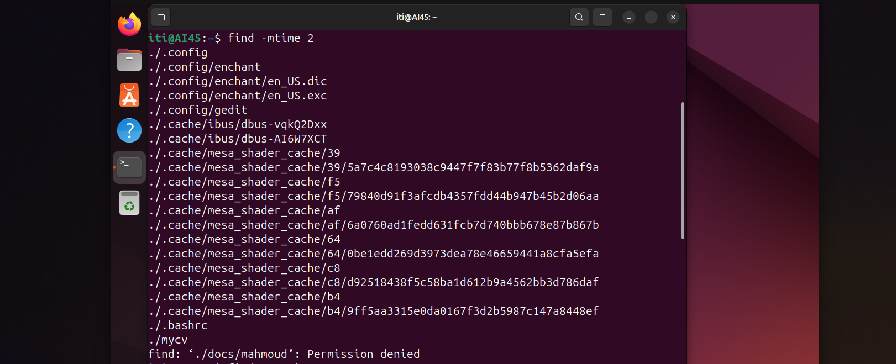

1. Starting from /etc, find files owned by root user.

1. Find all directories in your home directory.

1. Write a command to search for all files on the system that, its name is “.profile”.



1. Identify the file types of the following: /etc/passwd, /dev/pts/0, /etc, /dev/sda

1. List the inode numbers of /, /etc, /etc/hosts.

1. Copy /etc/passwd to your home directory, use the commands diff and cmp, and Edit in the file you copied, and then use these commands again, and check the output.

1. Create a symbolic link of /etc/passwd in /boot.

1. Create a hard link of /etc/passwd in /boot. Could you? Why?

yes

Hard links must exist all on the same device (partition, logical volume, etc).

